**Chương 2:**

**M1L2S1 - The Balance Sheet and The Income Statement**

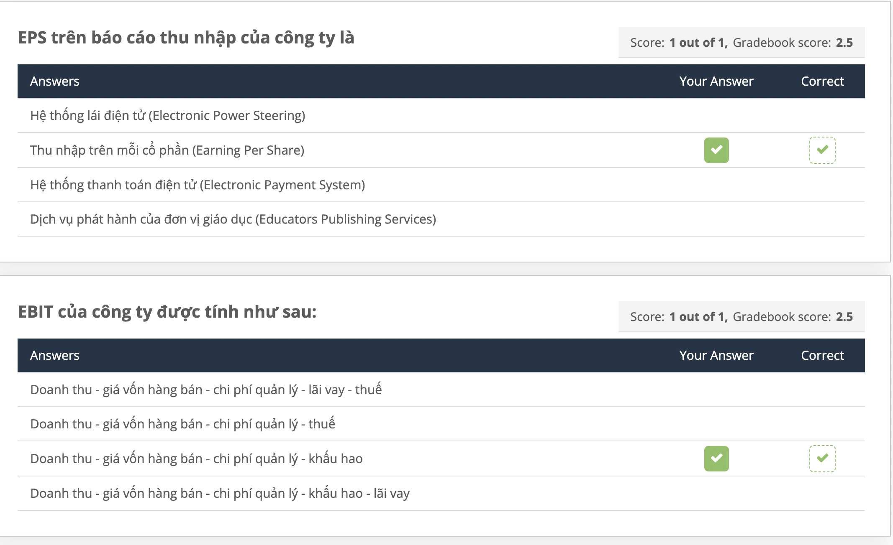

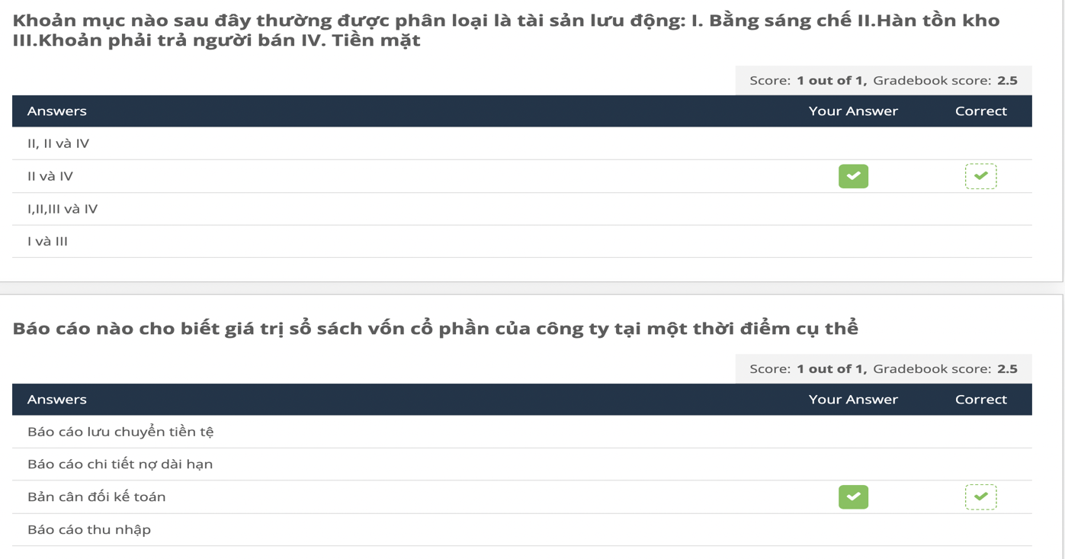

**M1L2S2 - Taxes**

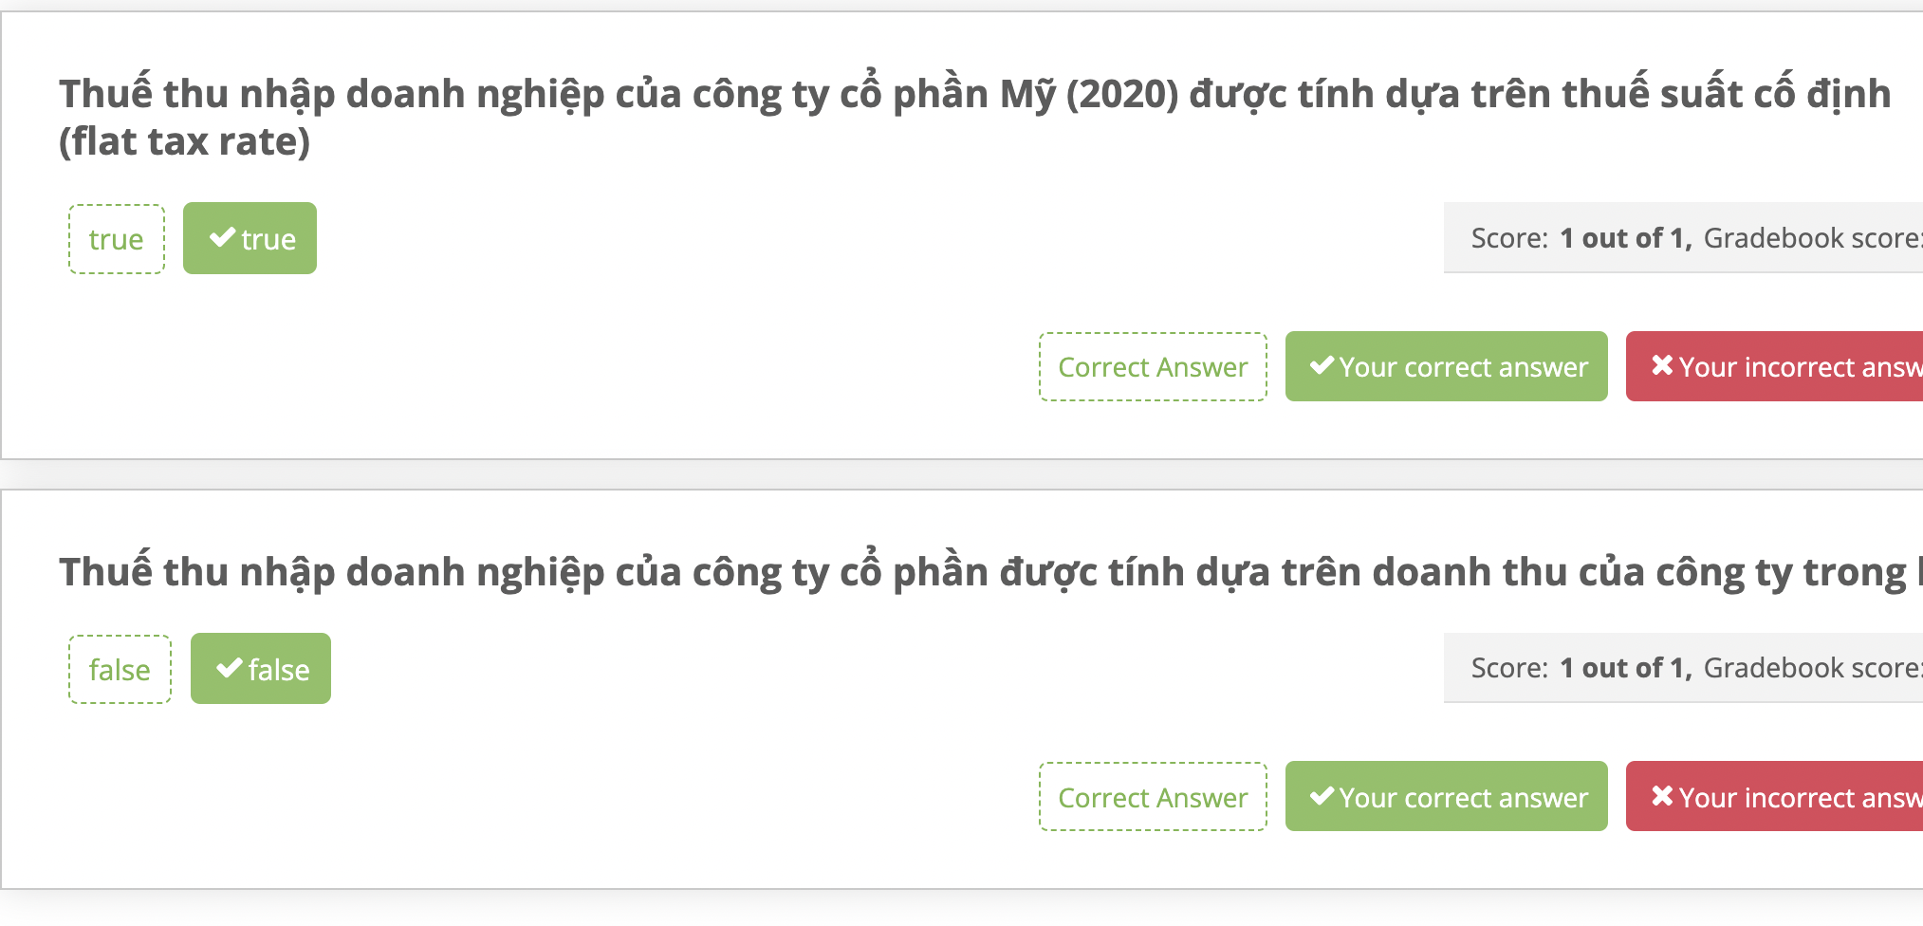

**M1L2S3 - Financial Cash Flows**

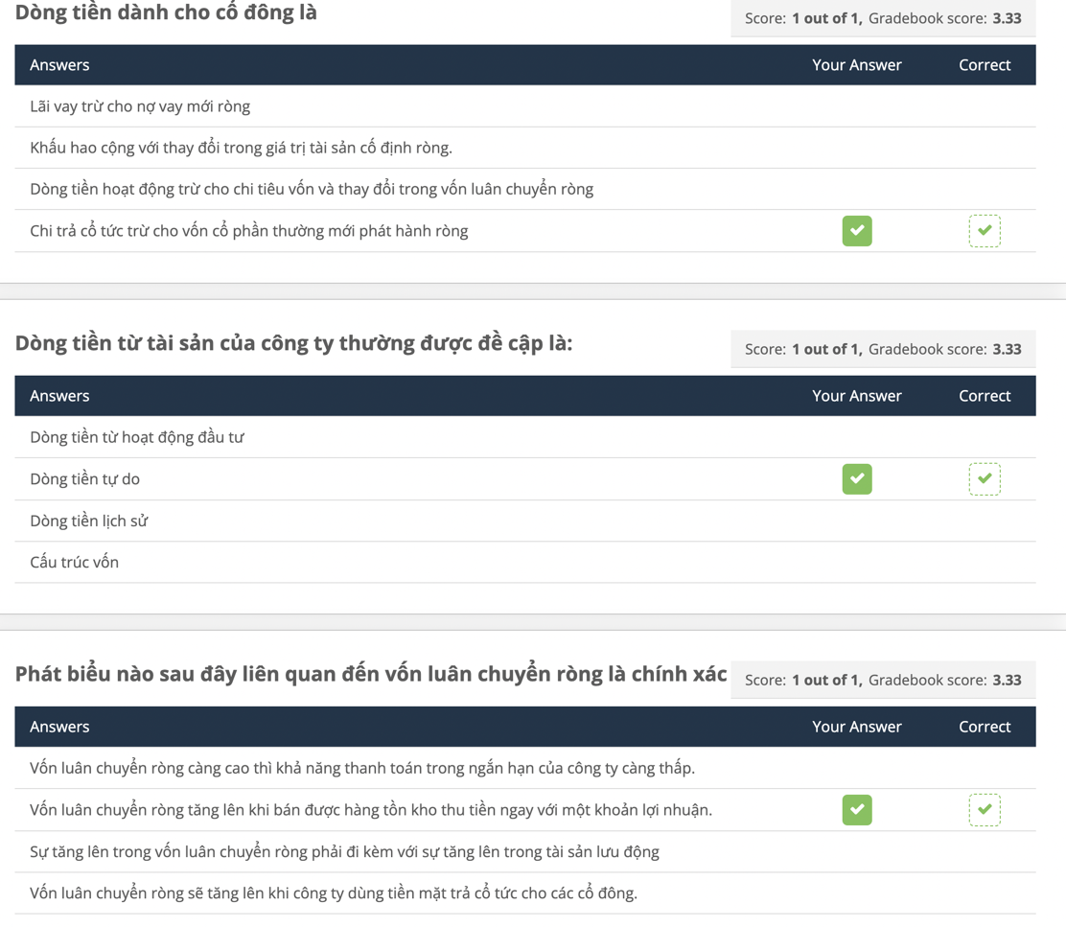

**M1L2S4 - Statement of Cash Flows**



**Chương 3:**

**M1L3S1 - Common size financial statements**

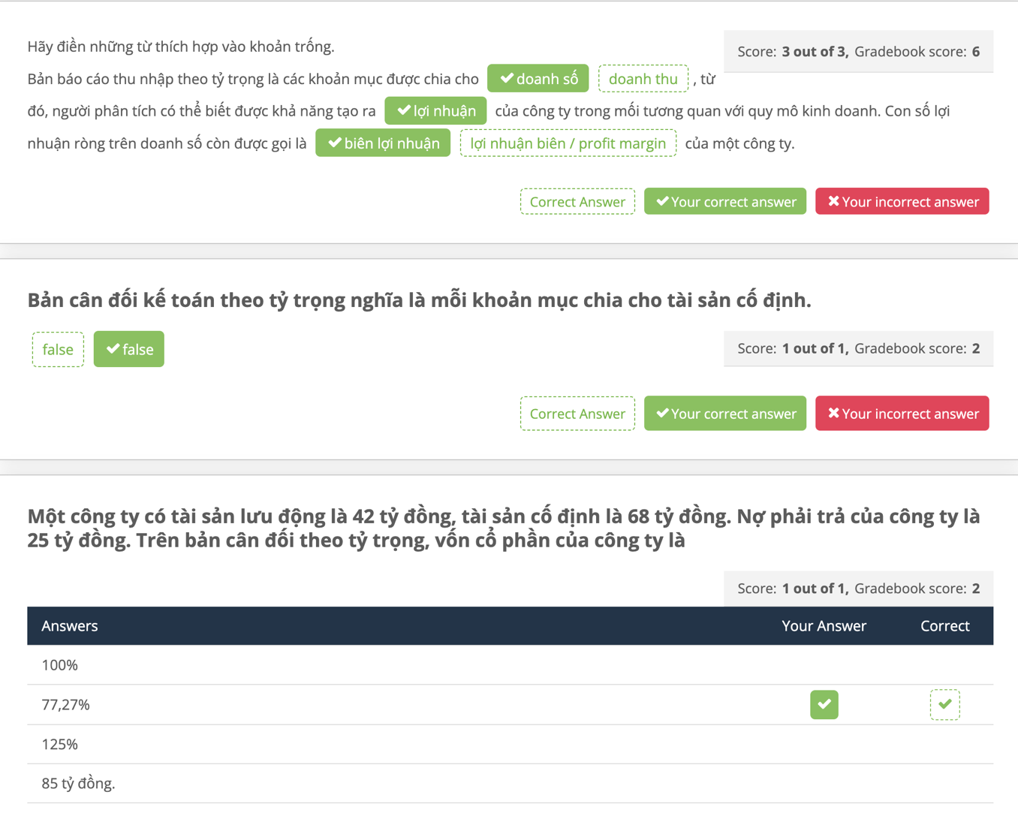

**M1L3S2 - Financial ratios**

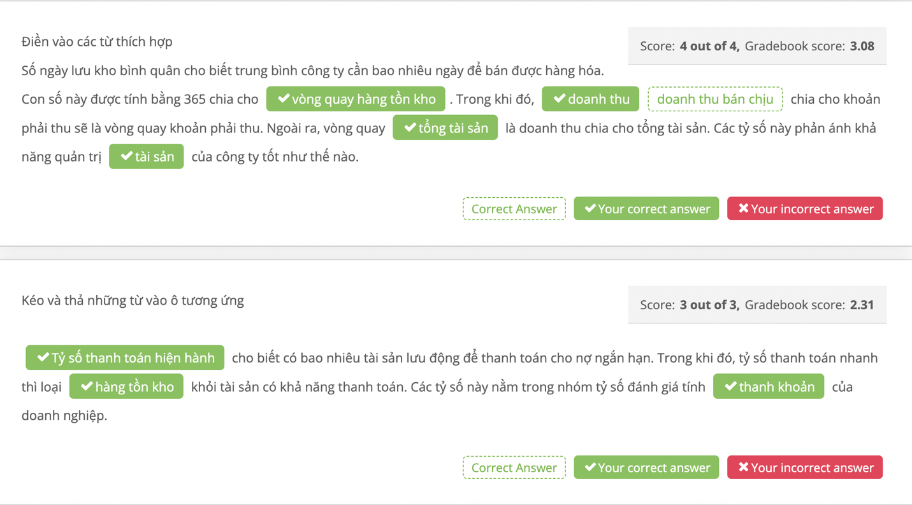

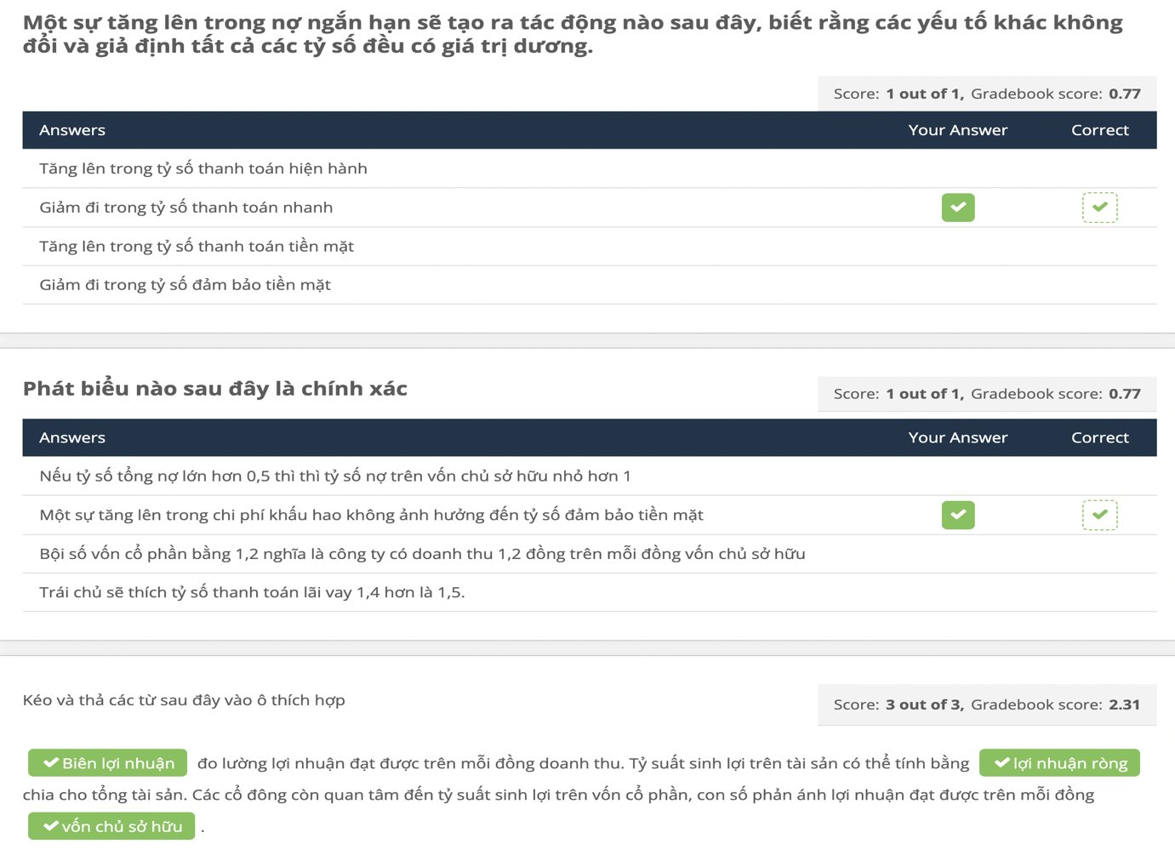

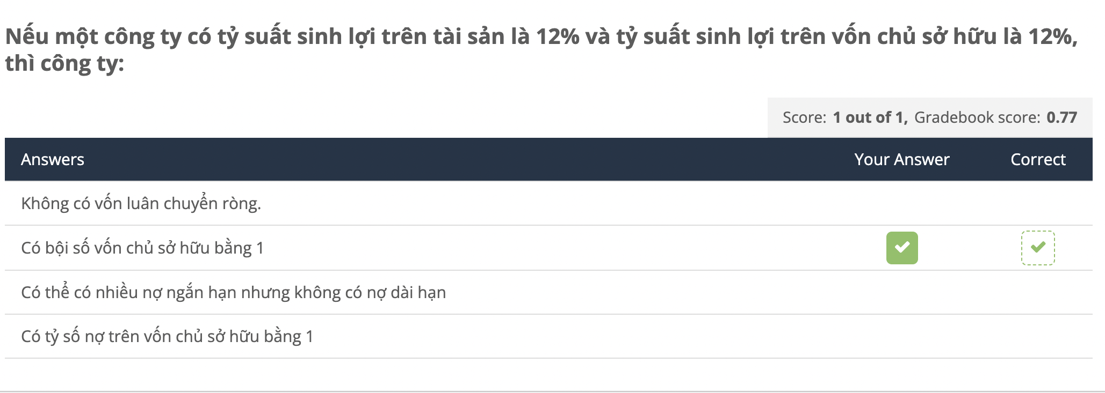

**M1L3S3 - DuPont Identity**

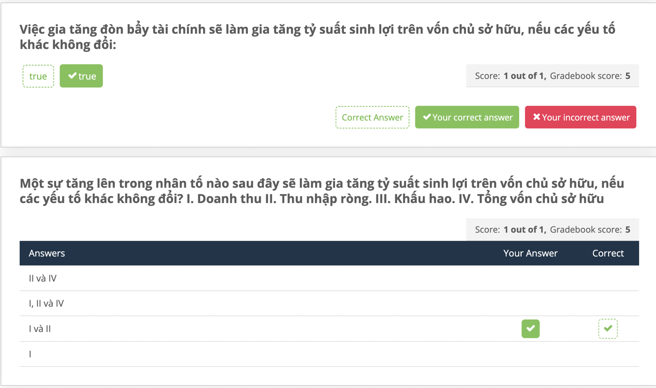

**M1L3S4 - Financial Planning**

